**Voice Mail System**

**Program Overview**

1. **Front end application**
   * Framework: Built using Tkinter for GUI development.
   * user authentication.
   * Allows users to send, receive, record and play voicemails via server.
2. **Backend application**:
   * Created a multithreaded server using Python’s socket.
   * Handles client connections.
   * Listens for connections, receiving messages, and sending.

### **Modules and Technologies Used**

* **Core Modules:**
  + socket: For server-client communication.
  + mysql.connector: To interact with a MySQL database
  + tkinter: GUI Interface .
  + threading: To handle continuous client connections to server
* **Database:**
  + Stores user accounts, voicemails has 2 tables
* **Audio Processing:**
  + pyaudio: Records audio input.
  + wave: to save audio in .wav form.
  + simpleaudio: to play audio messages.
* **Additional Utilities:**
  + os: perform file path operations.
  + time: generate timestamps.

### **Key Features**

1. **Database Operations**:
   * **User Authentication**: Validates login credentials by checking database.
   * **User Registration**: Add new users to the database
   * **Voicemail Metadata Management**: Saving and retrieving voicemail data.
2. **Server-Client Communication**:
   * Server listens on 127.0.0.1:12345.
   * The client connects to the server to send and receive voice mails
3. **Audio Recording and Playback**:
   * recording voicemails via pyaudio module.
   * Recorded files are saved as .wav by wave.
   * Voice messages can be played using simpleaudio.
4. **GUI**:
   * Main login-signup interface.
   * Contacts window displaying user list and received voicemails.
   * Buttons for recording, sending, and listening to voicemails.

**First page**

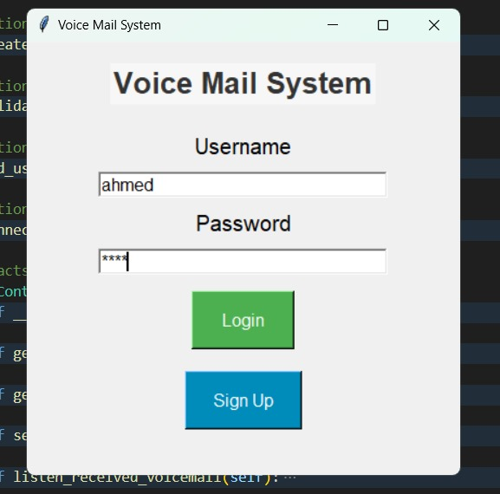

When you log in, the system checks your username and password to see if they match what's in the database.

* **If you don't have an account yet**: You'll be asked to sign up.
* **If your login details are correct**: You'll move on to the next page of the app.

**Codes used for the first page:**

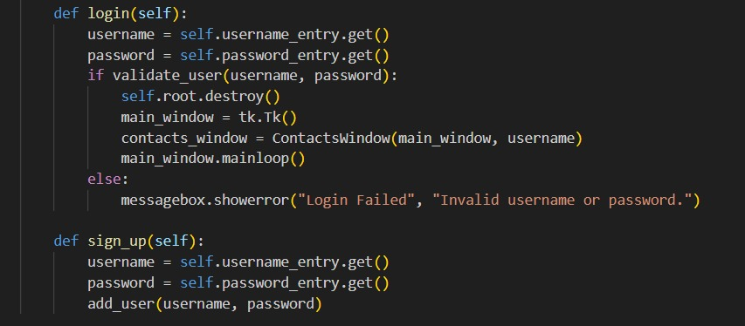

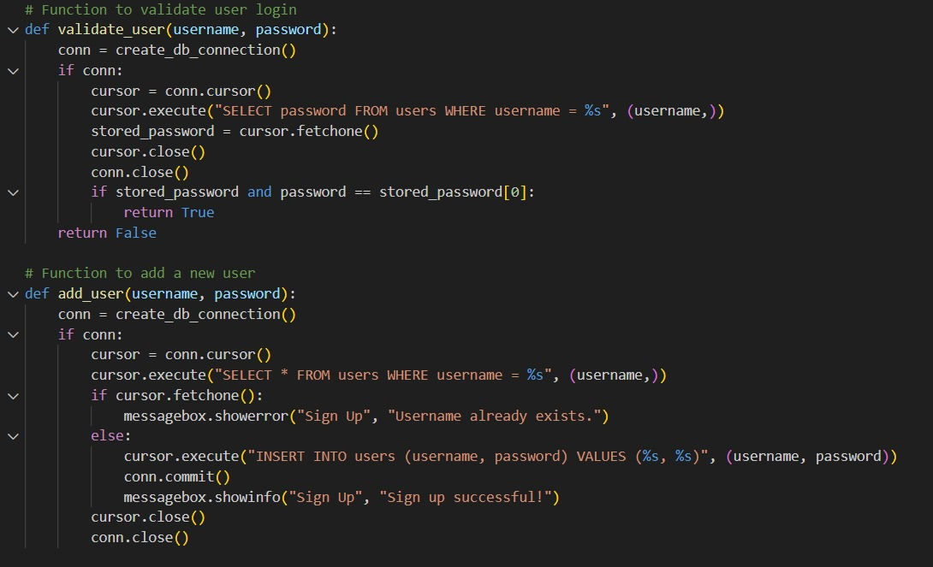

**Second Page**

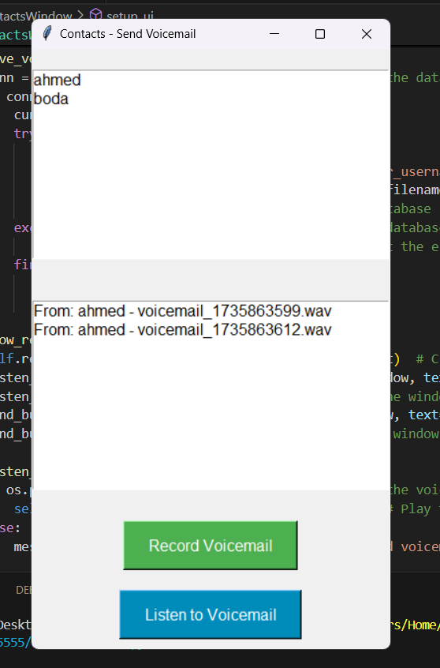

The interface includes two buttons and two list boxes :

* **List Boxes**:
  + One displays the user's contacts.
  + The other shows voicemails received by the user.
* **Buttons**:
  + **Record**: Allows users to record a new voicemail using the pyaudio module.
  + **Listen**: Plays the selected voicemail from the received messages list.

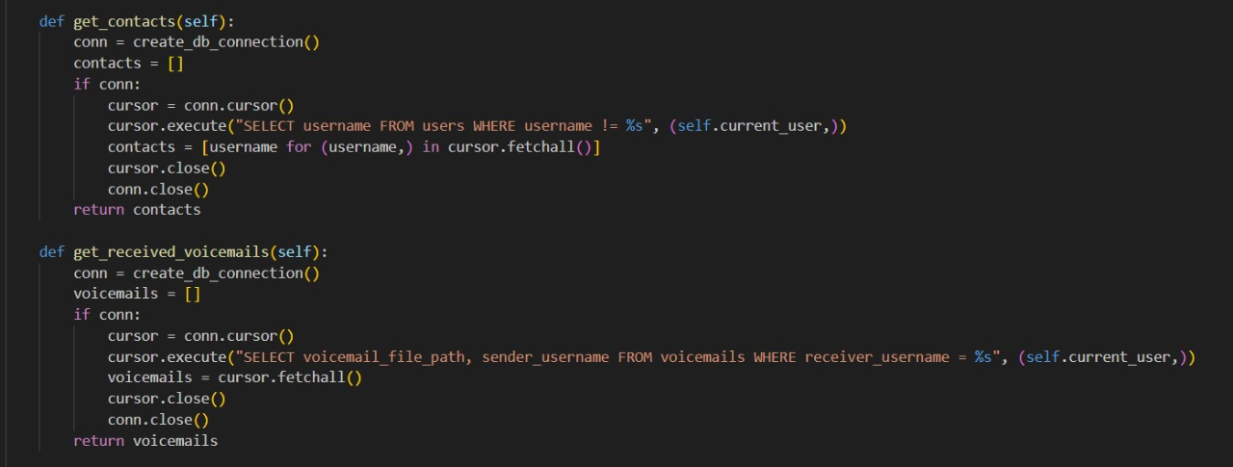**Functions for retrieving content in the two list boxes.**

**Code for listening to the received messages**

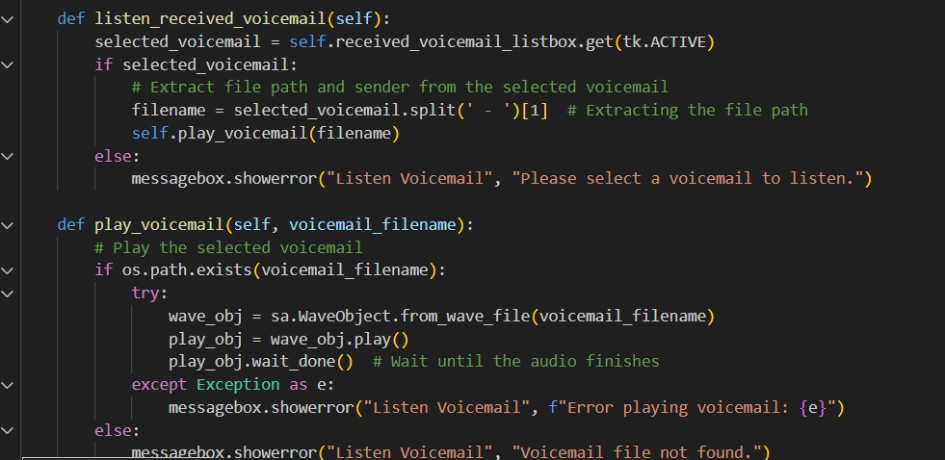

**Here we start Recording a message**

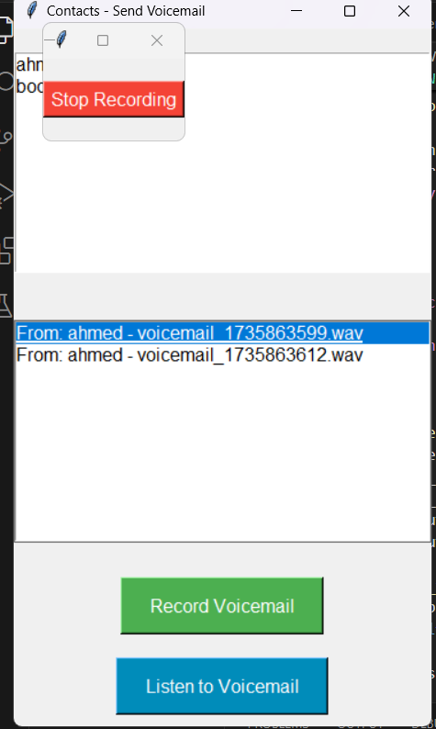

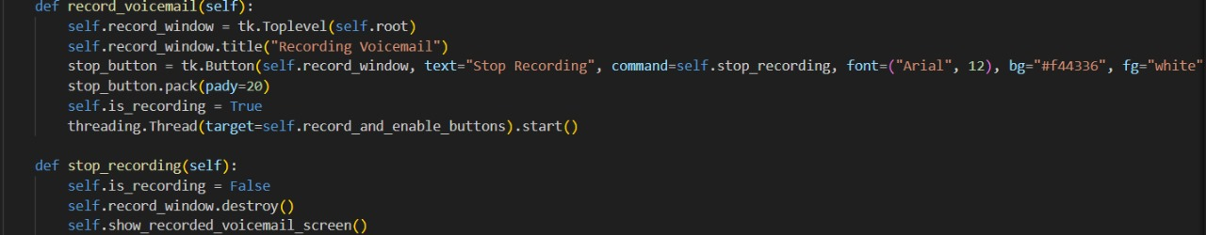

**After recording we have option to listen to the voice message before sending the message…**

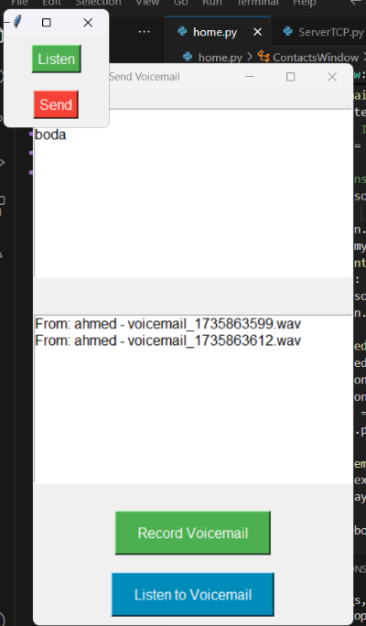

**This is code for the small screen after finishing recording.**

